SE Lab-3: Component Modelling & Architectural Pattern Selection
Adithya, PES1UG24CS021, 5A

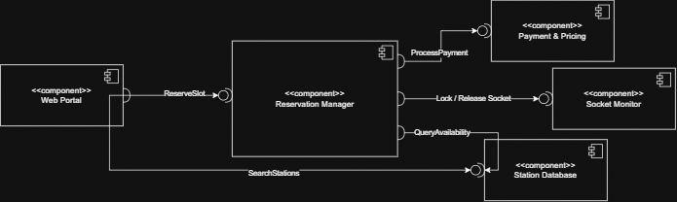

Justification for Architecture Choice:
Reason 1: The EV Charging Station system is a centralized web portal serving two actors (EV Driver, Station Operator), not a distributed network of services. Microservices Architecture would introduce unnecessary operational complexity and network latency for a system deployed as a single application. Layered Architecture provides clear separation of concerns within one deployable unit, which directly matches the system's operational scope.

Reason 2: Reservation operations require fast, transactional access to station availability data. In a Layered Architecture, the Reservation Manager communicates with the Station Database via in-process calls with zero network latency, ensuring instantaneous availability checks and preventing double-booking through database transactional integrity. Client-Server Architecture would add network round-trips and a single point of failure without any benefit for this single-application system.

Security Advantage: The layered structure isolates sensitive data, driver information, payment details, and penalty records, within the Business and Data layers. The Web Portal (Presentation layer) has no direct access to the Station Database; it communicates exclusively through the Reservation Manager, which enforces authorization checks and input validation before any data is read or written. This encapsulation significantly reduces the attack surface and prevents direct exploitation of the database layer.

Performance Benefit: All layers run on the same application server, so inter-layer communication uses in-process method calls rather than network requests. This eliminates network latency for critical operations like searching for available stations, checking slot availability, and completing reservations, essential when multiple EV drivers are concurrently searching for charging slots during peak hours.

